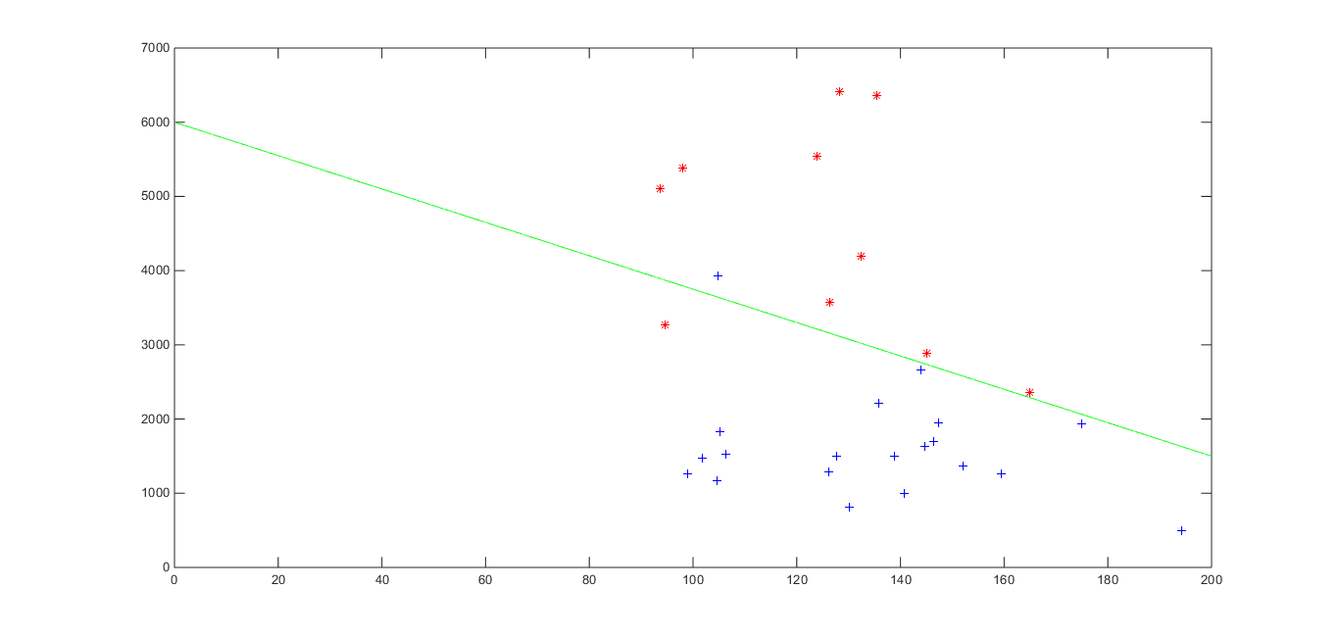

**Unsupervised Learning**

For this approach, we are still using the mean vs variance of the brightness as the feature to separate the data. To classify the data, we implemented k-means with of course two clusters. The k-means classifier correctly classified

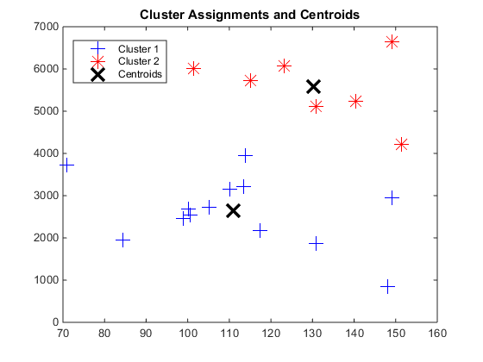

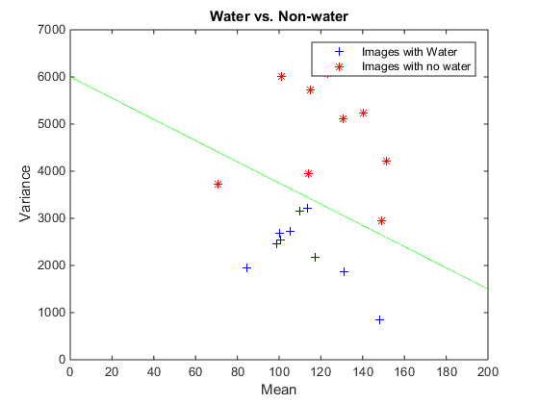

idx =

2(1)

2(2)

2(3)

2(4)

2(5)

1(6)

2(7)

1(8)

1(9)

2(10)

1

1

1

2

1

1

1

1

1

1

1

1

1

1

1

1

1

1

1

1